
DEVELOPERS.HUB CORPORATION
Cybersecurity Internship Program
SECURITY ASSESSMENT REPORT
Weeks 01 – 03 | Web Vulnerability Assessment, Security Hardening & Advanced Security
Intern Name | Ameer Hamza Khan
Intern ID | DHC-211
Team Leader | Faizan Khan
Report Period | 09 April 2026 – 21 April 2026
Environment | Docker + Kali Linux
Overall Risk Rating | CRITICAL → LOW (Post-Hardening)

"Security is a journey, not a destination."

Executive Summary
This consolidated report covers three weeks of hands-on cybersecurity internship work at Developers.Hub Corporation. The assessment progressed from vulnerability discovery to remediation and advanced security hardening on web applications running in a Docker + Kali Linux environment.

Vulnerabilities Found | Controls Implemented | Attacks Blocked | Final Risk Level
11 | 5 | 2 / 2 | LOW

- Week 01: SQL Injection (CVSS 9.8) and XSS (CVSS 8.2) successfully exploited on OWASP Juice Shop; 11 total vulnerabilities found via OWASP ZAP.
- Week 02: All 5 security controls implemented and verified — both attacks fully blocked on hardened Node.js application.
- Week 03: Nmap penetration test confirmed no unauthorized open ports; Winston logging implemented; full security checklist documented.

WEEK 01 — Web Application Vulnerability Assessment
Target: OWASP Juice Shop (http://localhost:3000)
Environment: Docker container on Kali Linux
Report Date: 09 April 2026

Environment Setup — Docker Pull
OWASP Juice Shop was deployed using Docker. The following screenshot shows the successful docker pull and container startup.
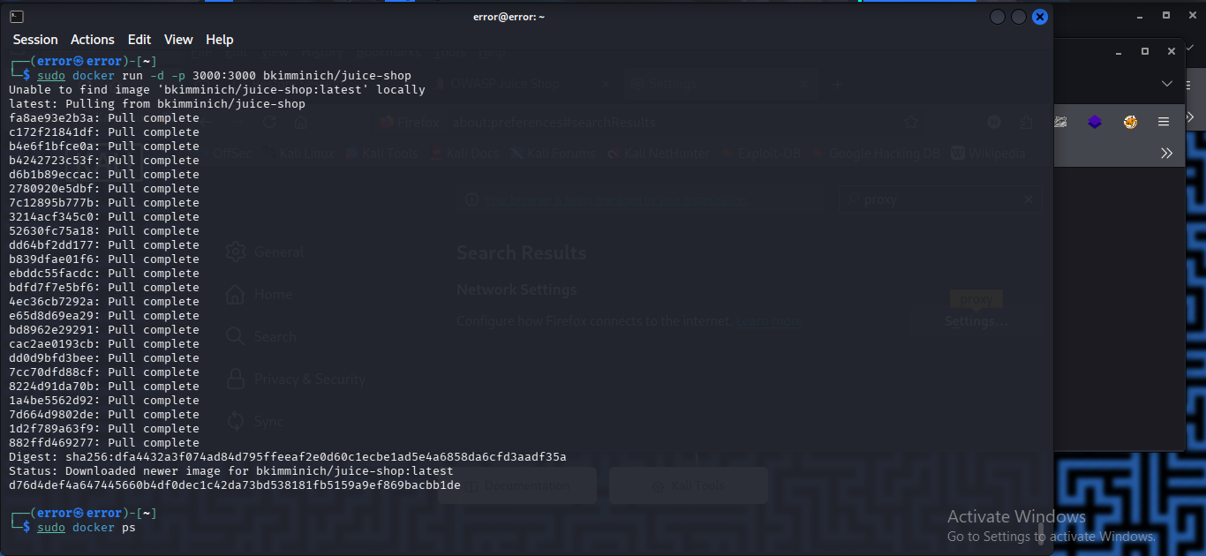
Fig 1.1 — Docker pull of bkimminich/juice-shop and container startup on Kali Linux

Vulnerability 1: SQL Injection
Severity | CRITICAL
CVSS Score | 9.8 / 10
Location | Login Page — Email Field
Payload | ' OR 1=1--
Impact | Complete authentication bypass — admin access without credentials
Root Cause | User input concatenated directly into SQL query; WHERE clause forced TRUE

The screenshot below shows the SQL injection payload in the email field and the successful admin login challenge completion:
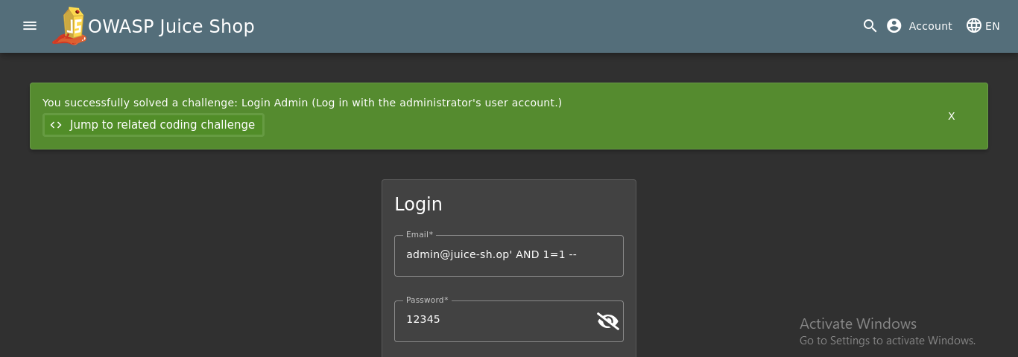
Fig 1.2 — SQL Injection successful: admin login bypass with ' OR 1=1-- payload

Vulnerability 2: Cross-Site Scripting (XSS)
Severity | HIGH
CVSS Score | 8.2 / 10
Location | Search Bar
Payload | <iframe src="javascript:alert('XSS')">
Impact | Cookie theft, user redirection, actions on behalf of victim
Root Cause | User input rendered in DOM without output encoding, allowing JS injection

The screenshot confirms JavaScript alert popup execution via iframe payload in the search bar:
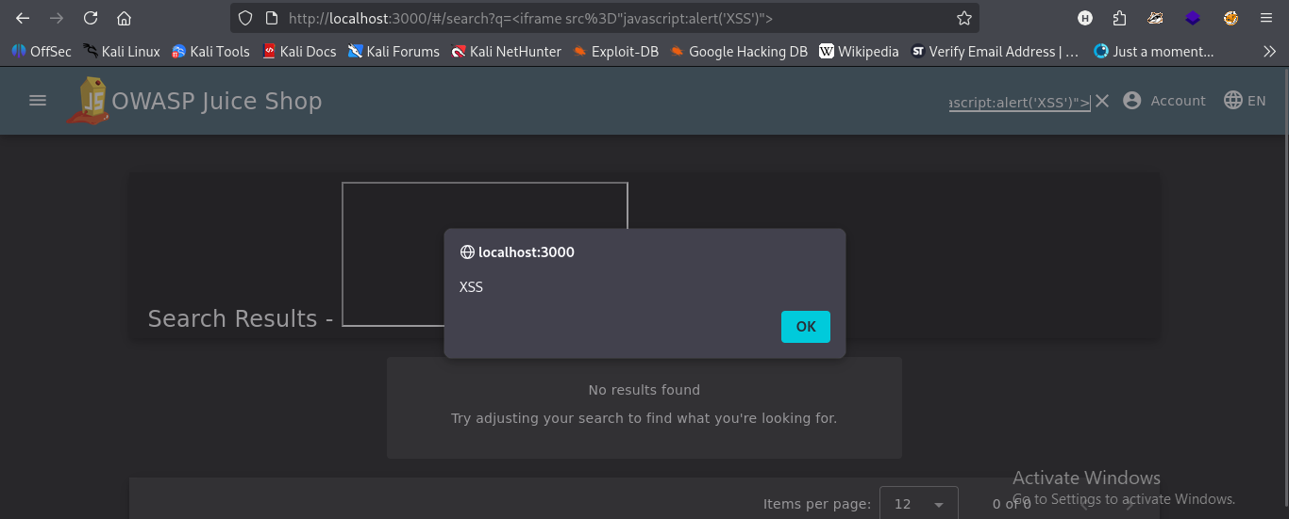
Fig 1.3 — XSS confirmed: alert('XSS') popup triggered via <iframe> payload in search bar

OWASP ZAP Automated Scan
OWASP ZAP was used for automated spider crawling and active scanning of the Juice Shop application.
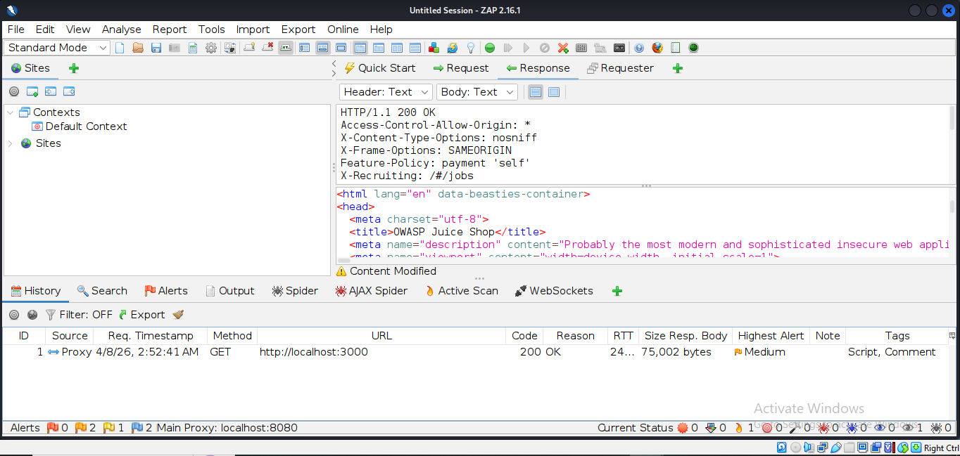
Fig 1.4 — OWASP ZAP scan results showing HTTP response headers and identified vulnerabilities

# | Finding | Location | Severity
1 | SQL Injection | /rest/products/search | CRITICAL
2 | Cross-Site Scripting (XSS) | Search Functionality | HIGH
3 | Information Disclosure | /metrics endpoint | MEDIUM
4 | Missing Security Headers | All Pages | MEDIUM

WEEK 02 — Security Hardening & Fixes
Target: Custom Node.js Web Application
Environment: Docker + Kali Linux
Report Date: 14 April 2026

Security Controls Implemented
# | Control | Implementation | Result
1 | Input Validation | validator.isEmail() rejects malformed inputs | SQLi & XSS BLOCKED
2 | Password Hashing | bcrypt.hash(password, 10) — 10 salt rounds | Plaintext ELIMINATED
3 | JWT Authentication | jwt.sign({email}, SECRET, {expiresIn: '1h'}) | Token Auth ACTIVE
4 | Secure HTTP Headers | app.use(helmet()) | Headers ADDED
5 | Protected Routes | Bearer token required for /profile | Auth Middleware ACTIVE

Test 1: SQL Injection — BLOCKED
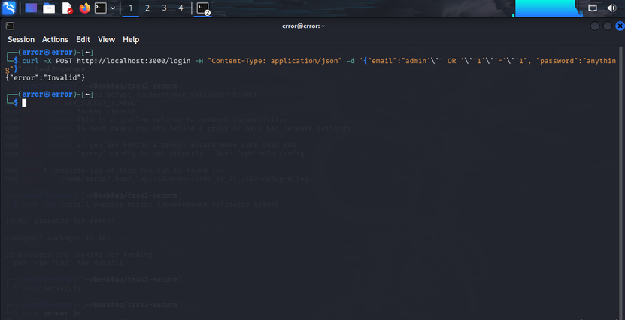
Fig 2.1 — SQL injection attempt returns {"error":"Invalid"} — BLOCKED

Test 2: XSS Attack — BLOCKED
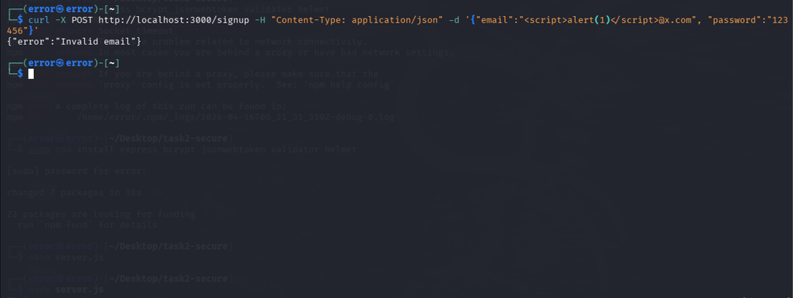
Fig 2.2 — XSS payload in email field returns {"error":"Invalid email"} — BLOCKED

Test 3: Valid Signup — SUCCESS
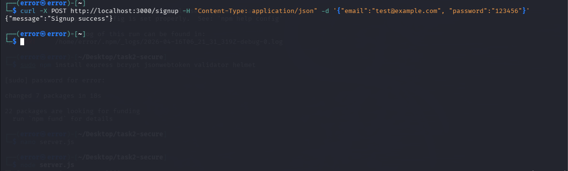
Fig 2.3 — Valid signup with test@example.com returns {"message":"Signup success"}

Test 4: JWT Token on Valid Login
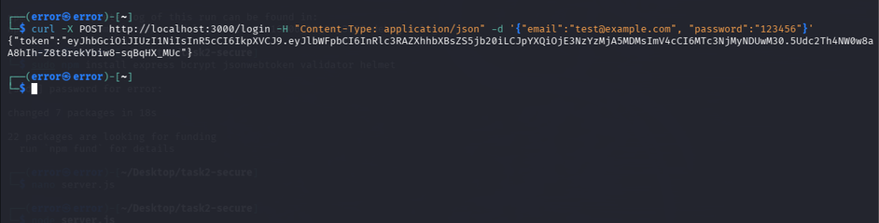
Fig 2.4 — Valid login returns JWT token starting with eyJhbGciOiJIUzI1NiIs...

Test 5: Protected Route Access
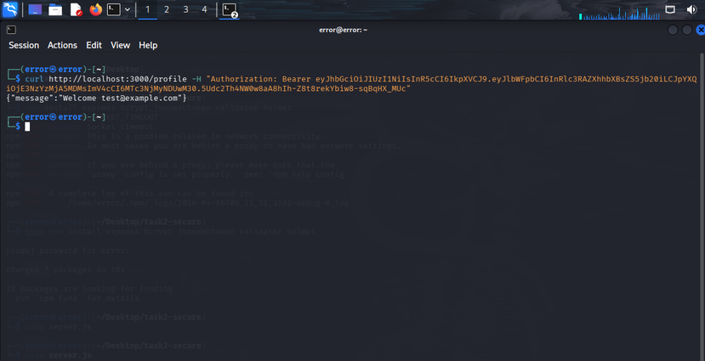
Fig 2.5 — /profile route returns welcome message only with valid Bearer token

Test 6: Helmet.js Security Headers
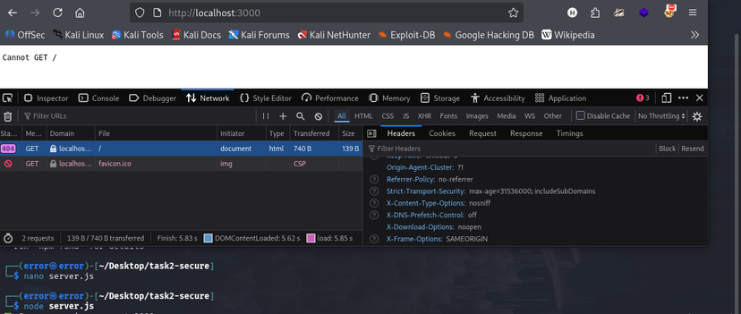
Fig 2.6 — Firefox DevTools confirming Helmet.js security headers: X-Frame-Options SAMEORIGIN, X-Content-Type-Options nosniff

Before vs. After Comparison
Vulnerability | BEFORE (Week 01) | AFTER (Week 02)
SQL Injection | Login bypass (CVSS 9.8) | BLOCKED — Input validated
XSS | Script execution in DOM (CVSS 8.2) | BLOCKED — Email format enforced
Password Storage | Plaintext storage | bcrypt hashed, 10 salt rounds
Authentication | No token mechanism | JWT with 1hr expiry
HTTP Headers | No security headers | Helmet.js — 4 headers added

WEEK 03 — Advanced Security & Final Reporting
Environment: Kali Linux
Report Date: 14 April 2026

Penetration Testing — Nmap Port Scan
Nmap (Network Mapper) was used to perform a version-detection scan on the application's port to verify its network footprint and confirm no unauthorized services were exposed.
Command: nmap -sV -p 3000 localhost

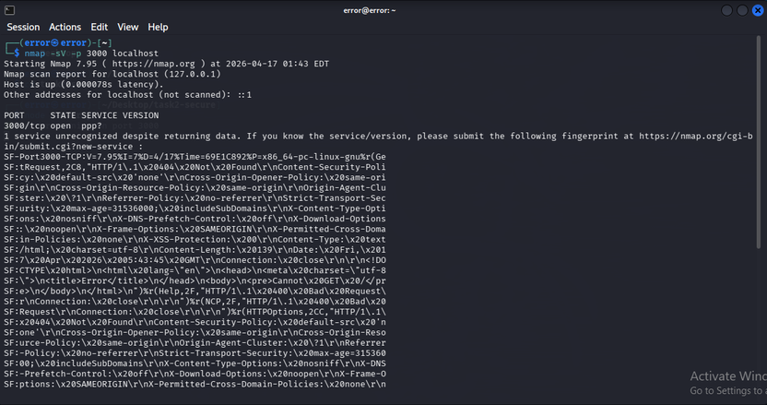
Fig 3.1 — Nmap scan confirming port 3000 open running Node.js Express; no unauthorized ports detected

Port | State | Service | Version / Notes
3000/tcp | OPEN | HTTP | Node.js Express — expected service
All other ports | CLOSED | — | No unauthorized open ports found

Logging — Winston Implementation
Winston was implemented for security logging, recording all important application events to both console and a security.log file.
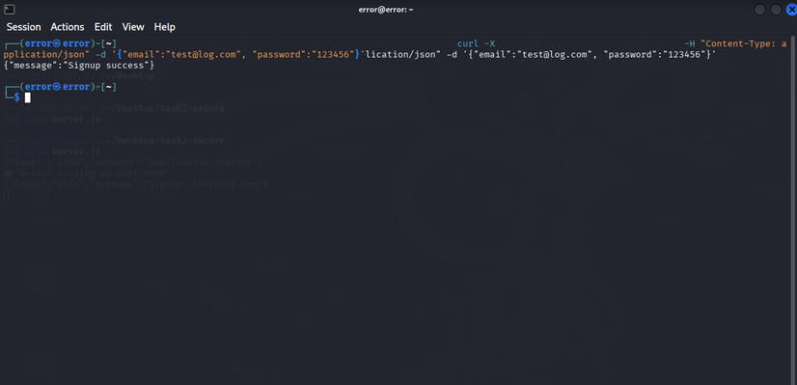
Fig 3.2 — Winston logging active: signup and application start events recorded in security.log

Security Checklist — Final Status
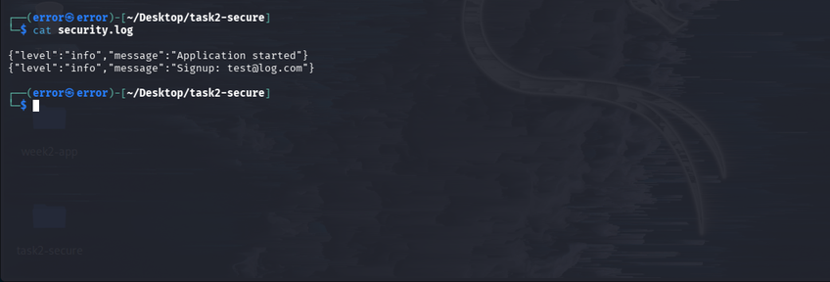
Fig 3.3 — Security checklist confirmation with Winston logs visible in terminal

Security Control | Status | Priority
Input Validation (Validator.js) | IMPLEMENTED | Critical
Password Hashing (bcrypt) | IMPLEMENTED | Critical
JWT Authentication | IMPLEMENTED | High
Secure HTTP Headers (Helmet.js) | IMPLEMENTED | High
Security Logging (Winston) | IMPLEMENTED | High
Penetration Test (Nmap) | COMPLETED | High
HTTPS / SSL Certificate | PENDING | Critical (Prod)
Rate Limiting | PENDING | High (Prod)
Environment Variables (.env) | PENDING | Medium (Prod)

Overall Conclusion & Summary

Three-Week Progress
Week | Focus | Key Achievement | Status
Week 01 | Vulnerability Assessment | 11 vulns found; SQLi + XSS exploited | COMPLETE
Week 02 | Security Hardening | 5 controls; all attacks blocked | COMPLETE
Week 03 | Advanced Security | Nmap + Winston + Checklist | COMPLETE

Key Takeaways
- Never trust user input — all inputs must be validated and sanitized before processing
- Parameterized queries are the only reliable defense against SQL Injection
- Output encoding prevents XSS by treating user data as data, not executable code
- Passwords must never be stored in plaintext — bcrypt with 10+ salt rounds is the standard
- Security headers (Helmet.js) add a critical extra layer of defense-in-depth
- Logging and monitoring are essential for detecting attacks and enabling incident response

Production Deployment Recommendations
- Enable HTTPS with a valid SSL/TLS certificate to encrypt all data in transit
- Implement rate limiting using express-rate-limit to prevent brute force attacks
- Move all secrets (JWT_SECRET, DB credentials) to environment variables (.env file)
- Run OWASP ZAP scans regularly in the CI/CD pipeline for continuous monitoring

All Week 1–3 objectives successfully completed. The application has been assessed, hardened, penetration tested, and documented.

Prepared by: Ameer Hamza Khan | ID: DHC-211 | 21 April 2026

